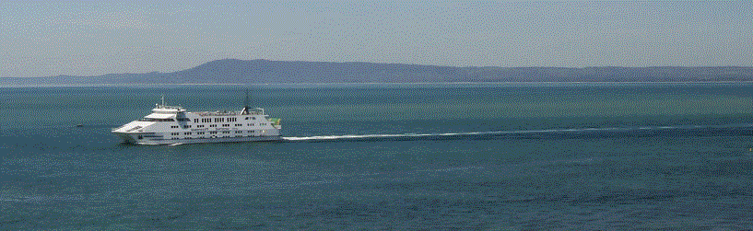

**Interfaith Youth Leadership Camp, 2020.**

**Tuesday 31st March–Thursday 2nd April** (3days/2 nights) during school holidays at Whitehall Guesthouse in Queenscliff [www.whitehallqueenscliff.com.au](http://www.whitehallqueenscliff.com.au).

**Faith communities with a link to Wyndham** can nominate **5 young leaders** (between 16 – 25 years old) to join others (30 places only). The camp is Co Ed with males and female accommodated on different floors of the facility.  F**aith leaders welcome to accompany young people** from their community as an observer and additional support. **Camp costs are covered but $20 (in cash) bond is needed to secure a place**. This to be paid at WCEC reception and collected after camp by receipt. The camp will be facilitated by Wyndham CEC, the Gandhi experiment and Victoria Police. It will be active, creative, reflective and fun.

* **Building understanding of leadership;**
* **Intercultural skills; Physical challenge**
* **World religions; and,**
* **Explore opportunity for social action**

Activities will also include mountain biking, a scavenger hunt, talent night and ferry crossing. Support will be available to plan further activities on leadership or social action. Check the experience of others from the 2019 camp. <https://www.youtube.com/watch?v=Sc3JiB40P3o>

To participate please complete a registration form and give to WCEC reception or send to [rsvp@wyndhamcec.org.au](mailto:rsvp@wyndhamcec.org.au) For further information contact Laurence Gray [laurenceg@wyndhamcec.org.au](mailto:laurenceg@wyndhamcec.org.au) 9742 4013.

